Press Release n. 4 | 2017

The TREASURE project is ready to run

Today the Kick off Meeting of the TREASURE project will be held at the University of Nottingham TREASURE stands for Training, REsearch and Applications network to Support the Ultimate Real time high accuracy EGNSS solution. TREASURE is coordinated by the University of Nottingham, the Istituto Nazionale di Geofisica e Vulcanologia (INGV) is one of the partners. TREASURE is an EU funded project under the H2020-Marie Skłodowska-Curie Innovative Training Network.
The aim of the four-year project is to provide instantaneous and high accuracy positioning anywhere in the world, exploiting the different satellite systems to operate together in a multi - Global Navigation Satellite Systems (multi-GNSS), to reach an accuracy of a few centimeters. By 2020 GALILEO, the European GNSS system (EGNSS) will be fully operational and provide positioning data of unprecedented accuracy. Its integration with other satellite systems, through Treasure project, is the key for increase the Europe’s competitiveness in the field of space technology, mainly based on the GPS system in the last 20 years.
A highly-accurate multi-GNSS service could assist not only the industry for the security like for the air\maritime navigation service but also the global Agri-Tech field. As an example, accurate real-time positioning data could be given to farmers in order to maximize food production, reduce costs and minimize environmental impact. Moreover, think about the offshore operations, a deep-sea drilling platform that experiences any temporary degradation of positioning accuracy could lead to phenomenal losses right at a time when, due to the current oil production climate, companies are striving to increase operational efficiency.
The project team will train and work alongside 13 Marie Skłodowska-Curie Fellows who will be earmarked as high-flying candidates for future employment in the burgeoning GNSS industry or as specialist researchers. Two of the thirteen positions will be at INGV, the calls for candidates are now open and will expire on March 13, 2017.
All candidates must comply with the Marie Sklodowska-Curie Actions eligibility requirements, in summary must be within the first four year of their research career, must not yet have been awared a doctoral degree and must carry out trans-national mobility and not have resided or carried out their main activity (work, studies, etc.) within the host country for more than 12 months in the three years immediately prior to recruitment.
The Gender Officer of the project and senior researcher at INGV, Giorgiana De Franceschi underlines as the Project pays attention to gender balance. The recruitment will aim for 50% female researchers. The role of the Gender Officer in ensuring the gender balance within the project will include the promotion of the role of women in the research carried out within TREASURE, an absolute commitment to ensure that women in the project are treated entirely equitably and fairly with regard to pay and conditions of

work and facilities that would be attractive for females such as for example the provision of highly commendable child-care.

Link
http://istituto.ingv.it/l-ingv/opportunita-di-lavoro-e-collaborazione/2017-concorsi-cartella-completa/assegni-e-borse-di-studio/english_version_-_call_n._1_rm2.pdf

http://istituto.ingv.it/l-ingv/opportunita-di-lavoro-e-collaborazione/2017-concorsi-cartella-completa/assegni-e-borse-di-studio/call_2_rm2_english_attach.pdf

Rome, 8th February 2017

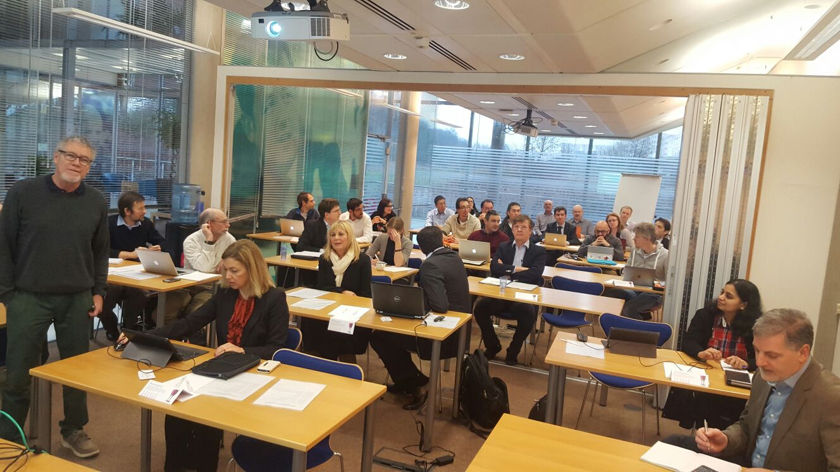
Kick off Meeting of the TREASURE project, University of Nottingham

Info:
Giorgiana De Franceschi, INGV, tel. 0039 06/51860307, cell. 0039 340/5537408, e-mail: giorgiana.defranceschi@ingv.it
Lucilla Alfonsi, INGV, tel. 0039 06/51860524, cell. 0039 339/2157287, e-mail: lucilla.alfonsi@ingv.it

