Press Release n. 2| 2017

The European Consortium for Research EMSO ERIC presented today at Foreign Press Association in Rome

‘’EMSO ERIC is crucial for obtaining coherent sets of data for the long term monitoring of the European seas and oceans. This data is crucial for addressing effects of climate change, but also for mitigating geo-hazards and increasing biodiversity safety’’, with these words Robert-Jan Smits, General Director of Directorate General for Research & Innovation RTD-European Commission, has gone straight to the core of innovation represented by the European Consortium EMSO ERIC, a research infrastructure in the field of marine sciences, composed of a network of automatic systems for monitoring distributed in the seas around Europe. EMSO ERIC, with headquarters in Rome had its launch-event held by Stampa Estera and was born under the protection of the European Commission. As Robert-Jan Smits explains, ‘’the EU has contributed €3.9 million of funding to the preparatory phase of this new European infrastructure and is providing additional support of €8.6 million to its implementation phase through Horizon 2020, the EU's research and innovation programme”. In the presentation event of EMSO ERIC, Carlo Doglioni, the President of the National Institute for Geophysics and Volcanology (INGV), Italy’s leading institution for EMSO ERIC, has remembered how a similar result represents ‘’the necessary and unquestionable European dimension for any successful collaboration in science, especially in the environmental sciences, while presently the ideal of unified Europe is put in doubt’’. The President of INGV has also explained how ‘’climate extreme events, such as the cold spell that has recently run Italy over, are expected to occur more and more often, being framed in the global climate changes, in which ocean has a regulating key-role’’.
Fulvio Esposito, technical secretary of Research Politics of the Department for Higher Education and Research of ‘’MIUR’’, has reminded us how the Ministry of Education, Universities and Research has decided to adopt the strengthening of research infrastructures as one of the main axes of the Italian National Programme for Research 2015-2020. Within this framework, EMSO, a Research Infrastructure of European interest, with its headquarters based in Italy, at the INGV, and with its network of prestigious research institutions at the forefront of the observation of the seafloor and water column, can provide an unprecedented amount of high quality data, freely available to a wide range of users, including of course scientists, but not limited to them. Therefore, besides extending the frontiers of our knowledge of crucial phenomena, such as the global change, EMSO has the potential to produce socio-economic benefits, especially if it will be able to interact with other challenge-oriented research hubs as, in the case of Italy, the National Technology Clusters. The launch-event of EMSO ERIC has included also the participation of Paolo Favali, the spokesperson of EMSO, who has explained to the audience of Italian and foreign journalists the past, the present and the future of EMSO ERIC, and of Richard Lampitt, from National Oceanography

Center UK, President of the Members’ Assembly of EMSO ERIC.

EMSO ERIC

The EMSO-ERIC, European Multidisciplinary Seafloor and Water Column Observatory – European Research Infrastructure Consortium has been created by eight countries: France, Greece, Ireland, Italy, Portugal, Romania, United Kingdom, Spain with its headquarters in Rome. The aim of the Consortium is to actively promote the European scientific research of the marine environment, under the aegis of the European Commission. INGV, National Institute of Geophysics and Volcanology is the leading partner of the consortium for Italy.
The infrastructure managed by the European consortium has a continental scale, and consists of long-term high-resolution observation systems with practically real-time monitoring. It is composed of 11 underwater observatories, set up at great depths, that provide large data flows, and 4 test sites in shallow waters that are monitoring the environmental processes affecting the geosphere, the biosphere and hydrosphere and their interactions. The sites are located in key spots, from the Arctic to the Atlantic Ocean and from the Mediterranean to the Black Sea, thus forming a European large scale infrastructure to the benefit of the international scientific community. This system allows to collect valuable data on natural hazards, climate change and marine ecosystems.
The ocean observatories are in constant development and are designed to communicate with multiple search platforms, allowing a continuous flow of data directly from the oceans and interactivity with their tools through direct connections and satellite broadcasts or the Internet

The scientific context

The oceans cover most of the planet’s surface - 70%, but this proportion is not reflected in scientific research: still many aspects of delicate relationship between the oceans and our ecosystem are not investigated and not fully understood. These unexplored aspects become even more important when you consider the pressure of the human activities and marine changes that result from it. If we think of the bigger picture, the study of the oceans allows us not only to better understand the physical, biological and chemical processes, but also the climate and geological ones. This becomes evident if we look at the map of the Earth faults. Fundamental questions of our future like biodiversity, climate evolution or how to coexist with natural disasters, can not stop at the borders of the land that has emerged above the sea level.
Scientific observation has opened this front of thought years ago, creating since the 90s a global network of ocean observatories that focus their activities on the bottom and on the seabed, as well as on the water column, but we are still far from a global vision of what happens in our oceans. The

sector is promising, because in the future it will allow us to understand epoch-making issues such as the influence of the oceans on the climate, the dynamics of marine lithosphere and to have a clearer vision of the earth's crust composition, to distinguish between natural changes and those induced on coastal environment, to understand the ecosystem dynamics and biodiversity. It is due to the marine research that scientists will be able to collect quality data and perform mapping over the years on the occasion of natural phenomena such as submarine volcanic eruptions, earthquakes, ocean currents, tsunami, instability of the seabed, and trace the biological, chemical and physical impact of the violent climate events.
Years of experience in the industry have created a network linked to numerous international programs, a global infrastructure that can connect new ongoing scientific experiences, where the main players are Japan, USA, Canada, Europe, but also other emerging ones, such as China.
In general the continuous and global monitoring of the ocean is a challenge comparable to exploration of space in its importance and difficulty: it is a careful study and optimization of spaces that can make a single infrastructure useful for multiple scientific objectives and also suited to the use of a large and diverse community of scholars, including biologists, oceanographers, geophysicists, chemists and engineers.
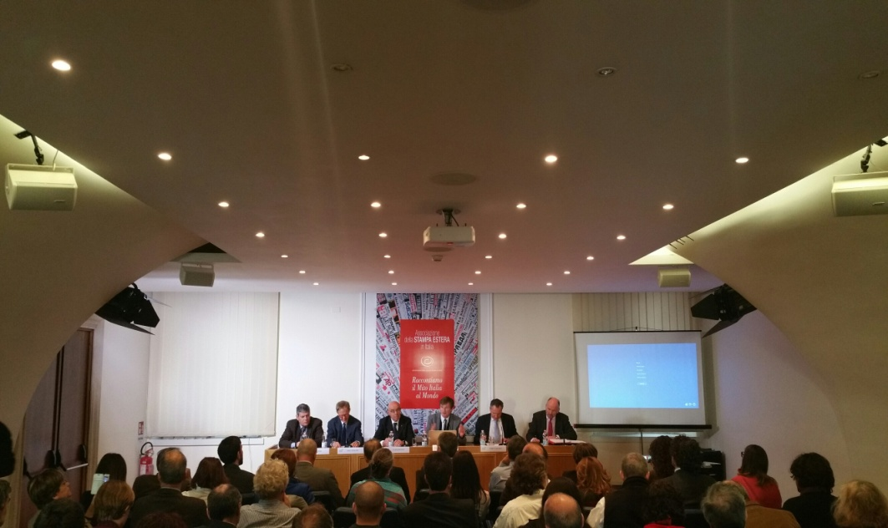

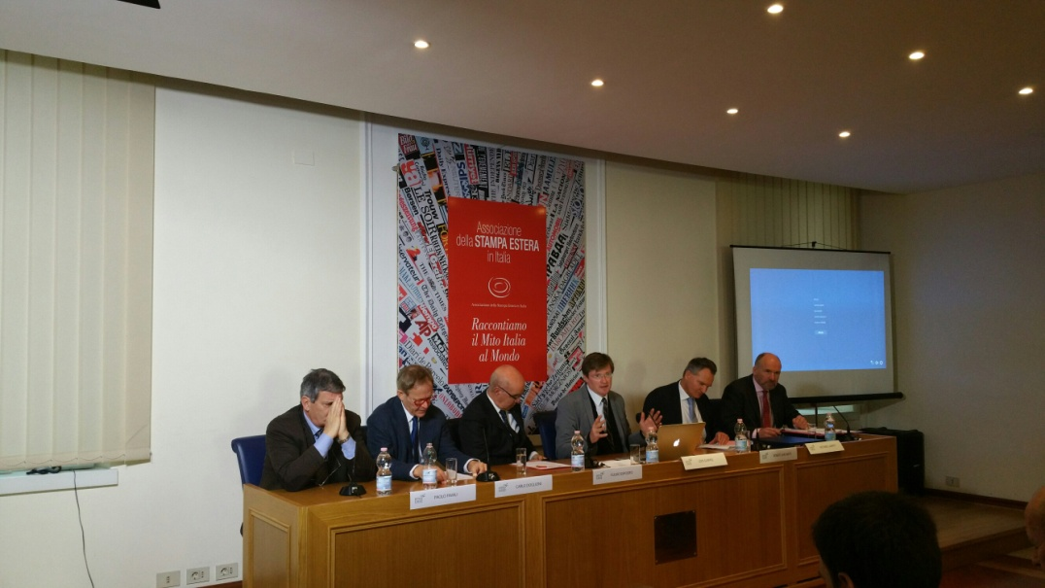

Rome, 27th January 2017

Info:
Laura Beranzoli, INGV, e-mail: laura.beranzoli@ingv.it, +39 3427321092
e-mail: ufficiostampa@pomilio.com, +39 333/2146503 – +39 349/6940150

